Power BI Assignment

Note: Solve all the powerbi assignments in a single Powerbi workbook and submit your assignment in .pbix format only.

Q1. Power BI Platform

What is PowerBI and What are the various Platforms of Power BI?

Q2. Dax

Create a line and clustered column chart and compare this year vs last year's sales along with growth % using DAX? Refer superstore dataset

Q3. Data Modeling

Import data from 2023 Worldwide Box Office - Box Office Mojo and add the past 3 years of data in the Power Query editor, create a master table of the past 3 years of data, and load only master data in the Power BI query editor or Power BI desktop?

Q4. Waterfall chart
Create the Waterfall Chart to show Category-wise, Yearly Analysis using Superstore Dataset.

Q5. Hierarchy: -

Create the Hierchey and rename with Location for Country-State-Region-City -Postal Code and Show the Location wise Sales using Superstore Dataset

Q6. Book mark
Create a clustered column chart referring to the order date, sales, cogs and profit, then apply bookmarks based on date Year, Quarter, and Month using Finance Dataset.
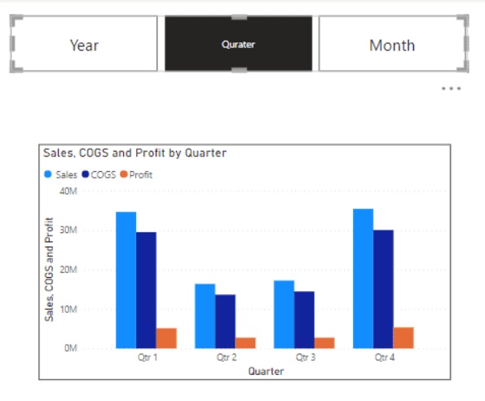

Q7. Drill through
Create Donut Chart to Show region wise Profit and Drill through the other page with West Region using Superstore Dataset

Q8. Conditional formatting
Using Superstore Dataset, create a table visual to show the Subcategory Wise Sales Profit Quantity Discount and Apply Conditional Formatting based on the below condition:
- Sales: Apply background color with lowest in red and highest in green.
- Profit: Use arrow icons, red for profit < 0 and green for profit > 0
- Quantity: Apply data bars.
- Discount: Set font color to red for lowest and green for highest.

Q9. Dashboard
Create the Finance Dashboard and add Navigation, Cards, Charts, Link to the Website and Slicer (Using Finance Dataset)

